**GameDesign – Edu game – Gamedesign les v1 5-11-2017**

1. **Teachings explanation**

This is a Game-Based Learning game that uses the knowledge already learned to the students by testing them on molecule combination to create new substances to solve puzzles. They learn this: Remembering, Understanding and use their knowledge by practicing it in the game.

the way children learn is divided in 6 topics:

* Motivation

The way this game keeps the player motivated is by focusing on fun instead of trying to force the idea that they really are learning

* Practice

The lessons they learned will be tested and practiced in this game this way they can use their knowledge learnt to solve puzzles.

* Feedback

The feed back exists out of taking away their resources if they are wrong. And if they are correct they can create a new substance, and if they solved the puzzle they get new resources.

* Memorizing

This way they can memorize molecular combining because they work with it in a fun way witch motivates the brain to remember more.

* Repeat

The player can keep failing and repeating as long as they have the resources and if they run out they can collect resources again from solved puzzles and random items in the levels.

* Failure

There is not really failure in the game the that does exist is that they can lose resources and if they start to run out the game gets harder.

1. **Premise**

The player is playable in a 2D environment and is needed to complete the levels by using molecular reactions to create new substances to create new ways to complete the levels.

1. **Player**

You play as a wizard that uses alchemy and is trying to proof the existence of chemistry

1. **[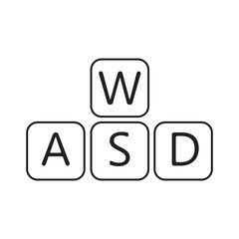](https://www.google.nl/url?sa=i&rct=j&q=&esrc=s&source=images&cd=&cad=rja&uact=8&ved=0ahUKEwivgdnKmafXAhXIqKQKHdAPBJkQjRwIBw&url=https://us.fotolia.com/tag/wasd&psig=AOvVaw3CDr7YU4FoAVKCNXhQHPKI&ust=1509963211803847)Controls / Mechanics**

The player moves using W-A-S-D from a top side view.

The player presses E to open the Periodic table and using that table he can create new substances

After he is successful the window closes and he can create the instance on his mouse position.

1. 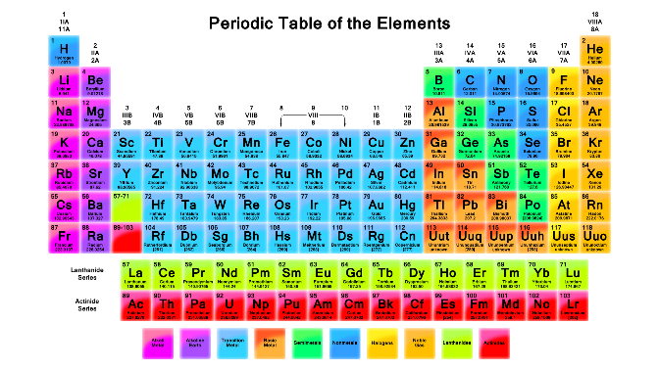**Resources**

The resources in this game exist out of the periodic table that you enlarge by solving puzzles and combining molecules so you can proceed further in the game.

The recources are:

* The elements on the periodic table.

1. **Antagonistic Elements**

There are no enemy’s in the game. The challenge in this game are the puzzles and the combination of molecules to create new substances.

Obstacles exist out of:

* Cliffs
* Lava
* Airwalls
* Water
* Fire

1. **Objectives / Goals**

Your objective as player is to complete the periodic table and use all the combinations you learned in one big puzzle

1. **Level design / GUI**

